A

Minor Project Report

on

**Automating Parking system using license plate detection**

Submitted in partial fulfillment of the requirements for the award of degree of

**Bachelor of Technology**

by

**Puneet Shekhawat**

**(CE-4111-2K16)**

**Pankaj Kumar**

**(CE-4102-2K16)**

Under supervision of

**Ms. Aayushi Bansal**



**Department of Computer Engineering**

**J. C. BOSE UNIVERSITY OF SCIENCE & TECHNOLOGY, YMCA**

**FARIDABAD-121006**

**May 2019**

**CANDIDATE’S DECLARATION**

I hereby certify that the work which is being presented in this project report titled **“Automating Parking System using license plate detection”** in fulfillment of the requirement for the degree of Bachelor of Technology and submitted to “**J. C. Bose** **University of Science and Technology, YMCA, Faridabad**”*,* is an authentic record of my own work carried out under the supervision of Ms Aayushi Bansal.

The work contained in this report has not been submitted to any other University or Institute for the award of any other degree or diploma by me.

**Puneet Shekhawat**

**(CE-4111-2K16)**

**Pankaj Kumar**

**(CE-4102-2K16)**

**CERTIFICATE**

This is to certify that the project report titled **“Automating Parking System using license plate detection”** submitted by **Puneet Shekhawat and Pankaj kumar** to “**J. C. Bose** **University of Science and Technology, YMCA, Faridabad**” for the award of the degree of Bachelor of Technology is a record of bonafide work carried out by her under my supervision. In my opinion, the work has reached the standards of fulfilling the requirements of the regulations to the degree

Ms. Aarushi

(Supervisor)

Assistant Professor,

Department of Computer Engg

J. C. Bose University of Science and Technology, YMCA, Faridabad

**LIST OF FIGURES**

**Figure Page No.**

Fig. 1 Image Processing Flowchart 10

Fig. 2 Process Chart 11

Fig. 3 Use case Diagram 19

Fig. 4 Class Diagram 41

Fig 5 Home Page

Fig 6 Registration Page

**TABLE OF CONTENTS**

|  |  |  |
| --- | --- | --- |
| **S. No.** | **Content** | **Page No.** |
| **1.** | **INTRODUCTION** | **1** |
| **2.** | **PROBLEM STATEMENT** | **2** |
| **3.**  **4.** | **OBJECTIVES & SCOPE**  **TECHNOLOGICAL STACK** |  |
| **5.** | **LITERATURE REVIEW** |  |
| **6.** | **PROPOSED METHODOLOGY(USE CASE DIAGRAM, DATAFLOW DIAGRAM, FLOWCHARTS)** |  |
| **7.** | **HARDWARE AND SOFTWARE REQUIREMENTS** |  |
| **8.** | **RESULTS (SCREENSHOTS, GRAPHS Etc.)** |  |
| **9.** | **CONCLUSION** |  |
|  |  |  |

**Introduction**

In last couple of decades, the number of vehicles has increased drastically. With this increase, it is becoming difficult to keep track of each vehicle for purpose of law enforcement and traffic management. License Plate Recognition is used increasingly nowadays for automatic toll collection, maintaining traffic activities and law enforcement. Many techniques have been proposed for plate detection, each having its own advantages and disadvantages.

License Plate recognition is one of the techniques used for vehicle identification purposes. The sole intention of this project is to find the most efficient way to recognize the registration information from the digital image (obtained from the camera). This process usually comprises of three steps. First step is the license plate localization, regardless of the license-plate size and orientation. The second step is the segmentation of the characters and last step is the recognition of the characters from the license plate. Thus, this project uncovers the fundamental idea of various algorithms required to accomplish character recognition from the license plate during Template Matching.

This feature of the algorithm mentioned above helped in achieving faster character recognition of the license plate. This process of character recognition consists of steps like Image processing, Defragmentation, Resizing and Character localization that are required to be performed on the image in order for Template Matching to be done.

In this approach, a digital camera is used to capture video and feed it to the kit. The kit processes each frame individually and provides the co-ordinates of location with maximum probability of having a number plate. Later, this information is used for v recognizing actual number of the license plate.

The proposed method uses image processing to verify the vehicle and open the gate to the parking lot. This technique addresses this issue by taking the image of the vehicle, locating the license plate and checking it with a database of registered license numbers within the system, hence maintaining security of the premises. One of reasons this specific technology (image processing), was employed was because its wide use in various fields of automation. The fact that this device can verify the car before it is allowed into the parking area, increases the security level. One of the more distinctive features of this concept is that the system is compact and dynamic, while being low cost. The system is expected to contain the database of the license numbers authorized to park in the premises.

This will also manage the number of cars present. The proposed system captures an image of the vehicle using a camera, so that the license plate can be located within the image. Once it has been located, the characters will be recognized using various image processing algorithms for optical character recognition. After the number is read, the device will decide whether the gate should open or not. The decision is taken by comparing the number with the database of authorized license numbers. Various algorithms and tools were employed in the image processing part of the system such as, image processing, pattern recognition and character recognition. These features helped in license plate detection and recognition. The device has certain restrictions when it comes to damaged license plate or improper lighting and hence were taken into consideration while analyzing the output. The other difficulties faced during the process include: Motion blur – Caused by the moving vehicles; poor file resolution – caused by low quality of camera or when the vehicle was too far away, varying templates of the number plates, etc. The dimensions and template of the Omani license plate was used for the machine training process of this device. The main focus for the results was reading the numbers clearly as opposed to the letters and the Arabic script on the plate. The basic idea of this project is versatile and can be modified to recognize any other license plate template. The concept employed in this device can be used not only in parking areas where there is a need for higher security such as government and certain commercial buildings, but also in toll booths, vehicle registration etc.

**Problem Statement**

Over the years, car parking systems and the accompanying technologies have increased and diversified. Car parking systems have been around almost since the time cars were invented. In any area where there is a significant amount of traffic, there are car parking systems

Parking a car in a parking lot takes huge amount of time. On entering a parking lot a car owner has to take parking ticket. These parking ticket have inflexible cost in cooperated with them.

This ticket system in parking area causes wastage of time. Customer identification and parking space management is another problem associated with them. The project helps in automatic customer identification from the license plate of the car entering the parking lot.

The customer registered with the parking lot will be automatically recognized using the license plate. The parking gates will be opened only the for customer registered with the

Parking lot. The customer will be charged for only the amount of time the parking lot is used.

Hence, promoting flexible charging scheme for the customer.

The parking lot will be well prepared for the customer registered, as the customer number and need will be known by the parking lot. The customer will find space in the parking at any time.

**TECHNOLOGY STACK**

**Pandas** : Pandas is a software library written for the Python programming language for data manipulation and analysis. In particular, it offers data structures and operations for manipulating numerical tables and time series. It is free software released under the three-clause BSD license. The name is derived from the term "panel data", an econometrics term for data sets that include observations over multiple time periods for the same individuals. DataFrame object for data manipulation with integrated indexing.

**Flask :** Flask is a micro web framework written in Python. It is classified as a microframework because it does not require particular tools or libraries. It has no database abstraction layer, form validation, or any other components where pre-existing third-party libraries provide common functions. However, Flask supports extensions that can add application features as if they were implemented in Flask itself. Extensions exist for object-relational mappers, form validation, upload handling, various open authentication technologies and several common framework related tools. Extensions are updated far more regularly than the core Flask program.

**Numpy :** NumPy is a module for Python. The name is an acronym for "Numeric Python" or "Numerical Python". It is an extension module for Python, mostly written in C. This makes sure that the precompiled mathematical and numerical functions and functionalities of Numpy guarantee great execution speed.

Furthermore, NumPy enriches the programming language Python with powerful data structures, implementing multi-dimensional arrays and matrices. These data structures guarantee efficient calculations with matrices and arrays. The implementation is even aiming at huge matrices and arrays, better know under the heading of "big data". Besides that the module supplies a large library of high-level mathematical functions to operate on these matrices and arrays.

**OpenCV :** OpenCV (Open Source Computer Vision Library) is an open source computer vision and machine learning software library. OpenCV was built to provide a common infrastructure for computer vision applications and to accelerate the use of machine perception in the commercial products. Being a BSD-licensed product, OpenCV makes it easy for businesses to utilize and modify the code.

The library has more than 2500 optimized algorithms, which includes a comprehensive set of both classic and state-of-the-art computer vision and machine learning algorithms. These algorithms can be used to detect and recognize faces, identify objects, classify human actions in videos, track camera movements, track moving objects, extract 3D models of objects, produce 3D point clouds from stereo cameras, stitch images together to produce a high resolution image of an entire scene, find similar images from an image database, remove red eyes from images taken using flash, follow eye movements, recognize scenery and establish markers to overlay it with augmented reality, etc. OpenCV has more than 47 thousand people of user community and estimated number of downloads exceeding 18 million. The library is used extensively in companies, research groups and by governmental bodies.

**HTML:** HTML is a computer language devised to allow website creation. These websites can then be viewed by anyone else connected to the Internet. It is relatively easy to learn, with the basics being accessible to most people in one sitting; and quite powerful in what it allows you to create. It is constantly undergoing revision and evolution to meet the and requirements of the growing Internet audience under the direction of the  W3C, the organisation charged with designing and maintaining the language.

HTML stands for Hypertext Markup Language, and it is the most widdemands ely used language to write Web Pages.Hypertext refers to the way in which Web pages (HTML documents) are linked together. Thus, the link available on a webpage is called Hypertext.

As its name suggests, HTML is a Markup Language which means you use HTML to simply "mark-up" a text document with tags that tell a Web browser how to structure it to display.

**CSS:** Cascading Style Sheets, fondly referred to as CSS, is a simple design language intended to simplify the process of making web pages presentable.CSS handles the look and feel part of a web page. Using CSS, you can control the color of the text, the style of fonts, the spacing between paragraphs, how columns are sized and laid out, what background images or colors are used, layout designs,variations in display for different devices and screen sizes as well as a variety of other effects.

CSS is easy to learn and understand but it provides powerful control over the presentation of an HTML document. Most commonly, CSS is combined with the markup languages HTML or XHTML.

**Bootstrap :** Bootstrap is a web framework that focuses on simplifying the development of informative web pages (as opposed to web apps). The primary purpose of adding it to a web project is to apply Bootstrap's choices of color, size, font and layout to that project. As such, the primary factor is whether the developers in charge find those choices to their liking. Once added to a project, Bootstrap provides basic style definitions for all HTML elements. The end result is a uniform appearance for prose, tables and form elements across web browsers. In addition, developers can take advantage of CSS classes defined in Bootstrap to further customize the appearance of their contents. For example, Bootstrap has provisioned for light- and dark-colored tables, page headings, more prominent pull quotes, and text with a highlight.

**DATABASE**

**MySQL:-**

MySQL is a fast, easy-to-use RDBMS being used for many small and big businesses. MySQL is developed, marketed and supported by MySQL AB, which is a Swedish company. MySQL is released under an open-source license. So you have nothing to pay to use it. MySQL is a very powerful program in its own right. It handles a large subset of the functionality of the most expensive and powerful database packages.MySQL uses a standard form of the well-known SQL data language.MySQL works on many operating systems and with many languages including PHP, PERL, C, C++, JAVA, etc.MySQL works very quickly and works well even with large data sets.MySQL is very friendly to PHP, the most appreciated language for web development.MySQL supports large databases, up to 50 million rows or more in a table. The default file size limit for a table is 4GB, but you can increase this (if your operating system can handle it) to a theoretical limit of 8 million terabytes (TB).MySQL is customizable. The open-source GPL license allows programmers to modify the MySQL software to fit their own specific environments.

**Objective and Scope**

**Objective:**

To automate parking lot by creating a database using the number plate recognized via image captured during the entrance of the vehicle in parking lot.

**Scope:**

License Plate recognition is one of the techniques used for vehicle identification purposes. The sole intention of this project is to find the most efficient way to recognize the registration information from the digital image (obtained from the camera). This process usually comprises of three steps. First step is the license plate localization, regardless of the license-plate size and orientation. The second step is the segmentation of the characters and last step is the recognition of the characters from the license plate. Thus, this project uncovers the fundamental idea of various algorithms required to accomplish character recognition from the license plate during Template Matching.

This feature of the algorithm mentioned above helped in achieving faster character recognition of the license plate. This process of character recognition consists of steps like Image processing, Defragmentation, Resizing and Character localization that are required to be performed on the image in order for Template Matching to be done.

License plate recognition can also be used to automate toll booths to speed up the process for collecting toll tax and avoiding parking jam at toll booths. This feature can be used for security purpose in society, organizations, companies etc.

**Literature review**

**Number Plate Detection**

Most of the number plate detection algorithms fall in more than one category based on different techniques. To detect vehicle number plate following factors should be considered: (1). Plate size: a plate can be of different size in a vehicle image.

(2). Plate location: a plate can be located anywhere in the vehicle.

(3). Plate background: A plate can have different background colors based on vehicle type. For example a government vehicle number plate might have different background than other public vehicles.

(4). Screw: A plate may have screw and that could be considered as a character.

A number plate can be extracted by using image segmentation method. There are numerous image segmentation methods available in various literatures. In most of the methods image binarization is used. Some authors use Otsu’s method for image binarization to convert color image to gray scale image. Some plate segmentation algorithms are based on color segmentation. In the following sections common number plate extraction methods are explained, which is followed by detailed discussion of image segmentation techniques adopted in various literature of ANPR or LPR.

*Image binarization*

Image binarization is a process to convert an image to black and white. In this method, certain threshold is chosen to classify certain pixels as black and certain pixels as white. But the main problem is how to choose correct threshold value for particular image. Sometimes it becomes very difficult or impossible to select optimal threshold value. Adaptive Thresholding can be used to overcome this problem. A threshold can be selected by user manually or it can be selected by an algorithm automatically which is known as automatic thresholding.

*Edge detection*

Edge detection is fundamental method for feature detection or feature extraction. In general case the result of applying edge detection of algorithm is an object boundary with connected curves. It becomes very difficult to apply this method to complex images as it might result with object boundary with not connected curves. Different edge detection algorithm / operators such as Canny, Canny-Deriche, Differential, Sobel, Prewitt and Roberts Cross are used for edge detection.

*Hough Transform*

It is a feature extraction technique initially used for line detection. Later on it has been extended to find position of arbitrary shape like circle or oval. The original algorithm was generalized by D.H. Ballard .

*Blob detection*

Blob detection is used to detect points or regions that differ in brightness or color as compared to surroundings. The main purpose of using this approach is to find complimentary regions which are not detected by edge detection or corner detection algorithms. Some common blob detectors are Laplacian of Gaussian (LoG), Difference of Gaussians (DoG), Determinant of Hessian (DoH), maximally stable extremal regions and Principle curvature based region detector.

*Connected Component Analysis (CCA)*

CCA or blob extraction is an approach to uniquely label subsets of connected components based on a given heuristic. It scans binary image and labels pixel as per connectivity conditions of current pixel such as North-East, North, NorthWest and West of the current pixel (8-connectivity). 4- connectivity is used for only north and west neighbour of current pixel. The algorithm gives better performance and it is very useful for automated image analysis. This method can be used in plate segmentation as well as character segmentation.

*Mathematical morphology*

Mathematical morphology is based on set theory, lattice theory, topology, and random functions. It is commonly applicable to digital image but can be used in other spatial structures also. Initially it was developed for processing binary images and then extended for processing gray scale functions and images. It contains basic operators such as Erosion, dilation, opening, closing.

*Countours*

Contours can be explained simply as a curve joining all the continuous points (along the boundary), having same color or intensity. The contours are a useful tool for shape analysis and object detection and recognition. To draw the contours, cv2.drawContours  function is used. It can also be used to draw any shape provided you have its boundary points. Its first argument is source image, second argument is the contours which should be passed as a Python list, third argument is index of contours (useful when drawing individual contour, to draw all contours, pass “-1” in function) and remaining arguments are color, thickness etc.

*Related work in number plate detection*

Images possess important details and pictorial information. These details are key parameters, used in various applications such as data storage, remote sensing, medical imaging, human computer interaction, machine learning, pattern recognition etc. This automatic parking management system locates the number plate and then uses character recognition to read the number and open the gate. In this project, a camera was used to capture an image of the vehicle. The device needs to extract certain features from the image, which provides it with relevant information. This process of feature extraction is known as image processing. Once the image is processed, decoding and location of the license plate number is performed. Image processing is a technique which takes an input in the form of an image and processes it to give specific parameters of the image as an output. It is done using mathematical operation and different algorithms applied over two dimensional layouts.

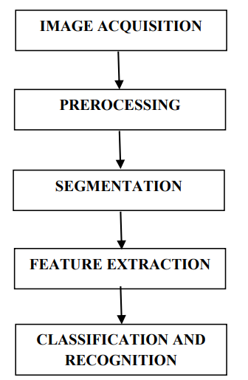

**Fig 1: Image Processing Flowchart**

The image processing steps that were used for number plate recognition in this device have been shown in “Fig. 1” flow diagram.

The first step is image acquisition, which means taking a digital image using camera. This image is then pre-processed to eliminate noise (converting colour to grayscale) and finding other parameters that increase the chances of detection of the number plate. After pre-processing, the image is segmented into sections for easier analysis. The segmentation process also reduces the chances of redundancy of the information present within the image. These sections are then again narrowed down in terms of their features for better recognition. This narrowing down of the image parameters to give specific features is known as feature extraction. The last step includes classification, which assigns each element that was gained from the previous steps a specific class (in this case number plates and non-number plates). These classes further attribute to the recognition of the license plate number.

The camera captures an image of the vehicle waiting for access to the parking lot. The pre-processing steps that the image goes through are: colour to grey conversion, sobel edge detection, threshold value, morphological operation and contouring. Once these processes are carried out, the image is simplified enough for the software to extract the required information. The next step is detecting the number plate from the modified image. Once the license plate is located, the algorithm for optical character recognition identifies numbers and characters and highlights them. The license number read is then compared and verified with the database. If that number is present in the database, an output signal is sent to the gate to open it.

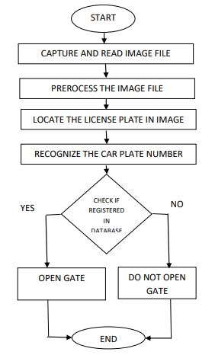

**Fig 2: Process chart**

The flow diagram shown in “fig. 2” gives a graphical representation of the steps the device carries out in one cycle of license plate recognition.

There are seven primary [algorithms](https://en.wikipedia.org/wiki/Algorithm) that the software requires for identifying a license plate:

1. Plate localization – responsible for finding and isolating the plate on the picture.
2. Plate orientation and sizing – compensates for the skew of the plate and adjusts the dimensions to the required size.
3. Normalization – adjusts the brightness and contrast of the image.
4. Character segmentation – finds the individual characters on the plates.
5. Optical character recognition.
6. Syntactical/Geometrical analysis – check characters and positions against country-specific rules.
7. The averaging of the recognised value over multiple fields/images to produce a more reliable or confident result. Especially since any single image may contain a reflected light flare, be partially obscured or other temporary effect.

The complexity of each of these subsections of the program determines the accuracy of the system. During the third phase (normalization), some systems use [edge detection](https://en.wikipedia.org/wiki/Edge_detection) techniques to increase the picture difference between the letters and the plate backing. A [median filter](https://en.wikipedia.org/wiki/Median_filter) may also be used to [reduce the visual noise](https://en.wikipedia.org/w/index.php?title=File_noise_reduction&action=edit&redlink=1) on the image.

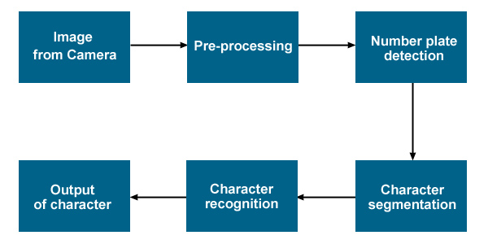

1. Pre-processing: The first step refers to process and prepare an image which is necessary for further license plate detection and character recognition. Pre-processing involves the digital filtering of an image. First, every colour image is converted into grayscale mode to preserve memory and speed up the further processing. This does not affect the useful data of the image.
2. Detection: According to the new conception of additional thresholding entirely black pixel rows appear repeatedly in the image after pre-processing. The white license plate area is situated somewhere between those black rows. By finding the longest vertical array of white pixels, it is possible to detect the left and the right edge of the license plate. When analyzing the image from left to right, the first longest vertical array of white pixels represents the left edge of the license plate. Accordingly, the last white column of the same size represents the right edge of the license plate. By finding the longest horizontal array of white pixels, it is possible to detect the top and the bottom of the license plate. It is enough to know the position of these license plate edges to detect the coordinates of the license plate.
3. Segmentation: The next step is the segmentation of the license plate area into smaller parts each representing a character of the license plate. We often apply the adaptive thresholding filter to enhance an area of the plate before the segmentation. The adaptive thresholding is used to separate dark foreground from light background with non-uniform illumination. Vertical projection of a binary image looks like a set of black hills on a white surface. This is obtained by counting the number of black pixels in each column. Columns without black pixels represent the spacing between each character. Coordinates of each character are then determined with alternatively found left and right hill edge
4. Recognition: The process of character recognition is repeated for each character image obtained in the last step. This process can be carried out in several steps. The output of this process should be a recognized character. The set of possible outputs are characters appearing on license plates, which can be alphabetic letters, numbers from 0 to 9 and special characters like the dash. Algorithms also look for characters equal in color and equidistance, with similar font structure to break apart each individual character. This sequential congruency of the characters embodies a characteristic set that is typically uniform, regardless of the type of license plate. Character Segmentation separates each letter or number where it is subsequently processed by optical character recognition algorithms. In order to simplify recognition, the initial step is to separate the possible outputs into smaller groups by counting the character end points. There are situations when the recognition mechanism fails, in these cases it is possibile to detect the failure by a syntactical analysis of the recognized plate. If we have country-specific rules for the plates, we can evaluate the validity of that plate towards these rules. Automatic syntax-based correction of plate numbers can increase the recognition abilities of the whole ANPR system.

**UML Diagrams:**

**Use-Case Diagram**:

Actor: User

Use Case: Capture image C1, Verify Vehicle, identify Number

Precondition: Vehicle will stop at gate, then take picture.

Post condition: If vehicle is not verifiable prompt a message to register.

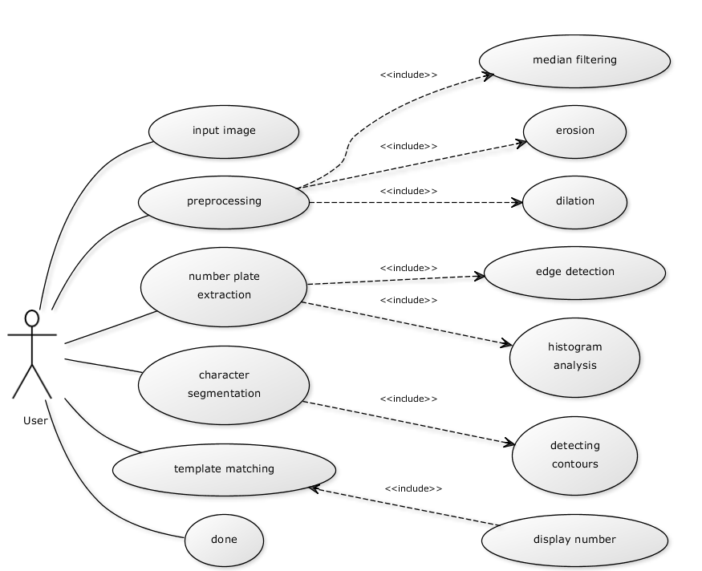

**Fig 3: Use case diagram**

**Class Diagram:**

The entities participating in the use case are camera, Image identifier, Database, Valid vehicle.

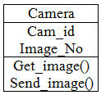 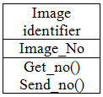

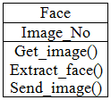

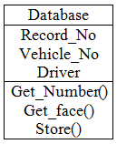 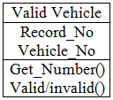

**Fig 4: Class diagram**

**SOFTWARE AND HARDWARE REQUIREMENTS**

Below is a list of the minimum Hardware and Software requirements.

**Operating System:**

* Windows 7, Windows 8 or Windows 10
* Mac OSX 10.8, 10.9, 10.10 or 10.11

**Hardware:**

* Processor (CPU) with 2 gigahertz (GHz) frequency or above
* A minimum of 1 GB of RAM
* Monitor Resolution 1024 X 768 or higher
* A minimum of 1 GB of available space on the hard disk
* Internet Connection Broadband (high-speed) Internet connection with a speed of 0.1 Mbps or higher
* Keyboard and a Microsoft Mouse or some other compatible pointing device.

**Software:**

*1) .XAMPP***:-**XAMPP is a software distribution which provides the Apache web server, MySQL database (actually MariaDB), Php and Perl (as command-line executables and Apache modules) all in one package. It is available for Windows, MAC and Linux systems. No configuration is necessary to integrate Php with MySQL.It is a great fit for this course and provides a relatively painless installation and way to manage the configuration changes. Also provided is PhpMyadmin which gives a GUI tool for managing your MySQL databases.I would highly recommend installing this for Windows or MAC. It doesn't exclude you from other competing software installations, it just gives an easy way to get going. For Ubuntu Linux systems, I still would recommend installing Apache/MySQL/Php/PhpMyadmin through Ubuntu packages.

The XAMPP download site: <https://www.apachefriends.org/>

2)*ANACONDA*:Anaconda is a free and open-source distribution of the Python and R programming languages for scientific computing (data science, machine learning applications, large-scale data processing, predictive analytics, etc.), that aims to simplify package management and deployment. Package versions are managed by the package management system conda. The Anaconda distribution is used by over 13 million users and includes more than 1400 popular data-science packages suitable for Windows, Linux, and MacOS.

Download and install Anaconda (windows version) from <http://www.anaconda.com>.

*3).Python:*Python is an interpreted, object-oriented, high-level programming language with dynamic semantics. Its high-level built in data structures, combined with dynamic typing and dynamic binding, make it very attractive for Rapid Application Development, as well as for use as a scripting or glue language to connect existing components together. Python's simple, easy to learn syntax emphasizes readability and therefore reduces the cost of program maintenance. Python supports modules and packages, which encourages program modularity and code reuse. The Python interpreter and the extensive standard library are available in source or binary form without charge for all major platforms, and can be freely distributed.

Download and install from <http://python.org>.

*4)VScode:* Visual Studio Code is a source-code editor developed by Microsoft for Windows, Linux and macOS.It includes support for debugging, embedded Git control and GitHub, syntax highlighting, intelligent code completion, snippets, and code refactoring. It is highly customizable, allowing users to change the theme, keyboard shortcuts, preferences, and install extensions that add additional functionality. The source code is free and open source and released under the permissive MIT License. The compiled binaries are freeware and free for private or commercial use.

Download and install from <https://code.visualstudio.com/>

**Browsers:**

* Chrome* 36+
* Edge* 20+
* Mozilla Firefox 31+
* Internet Explorer 11+ (Windows only)
* Safari 6+ (MacOS only)

**Result**

The web page for the parking lot is given below

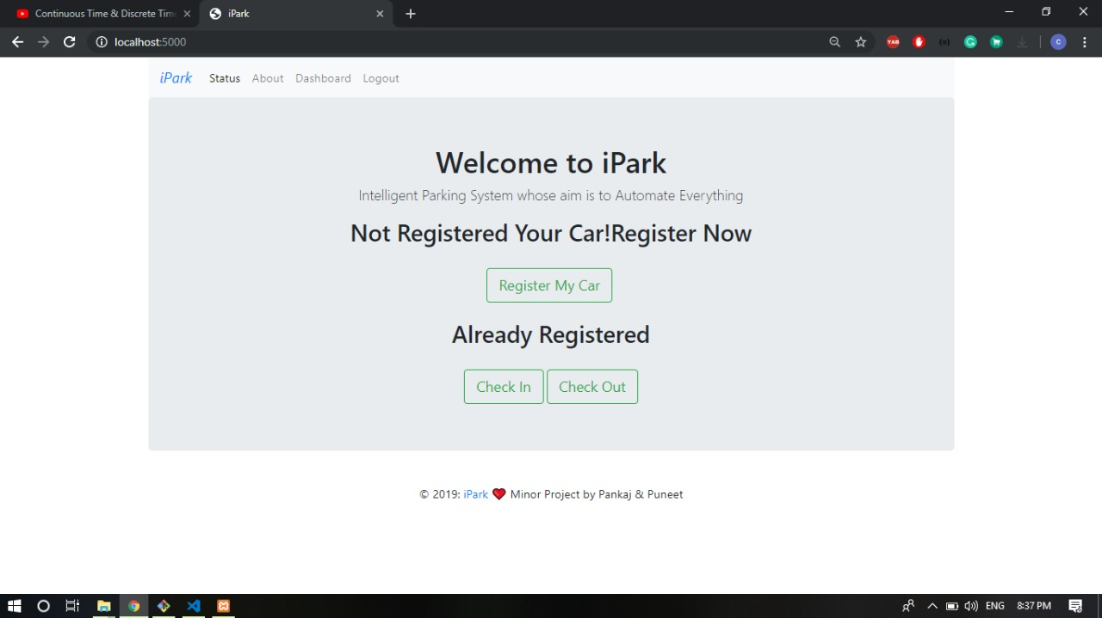

**Fig 5: Home Page**

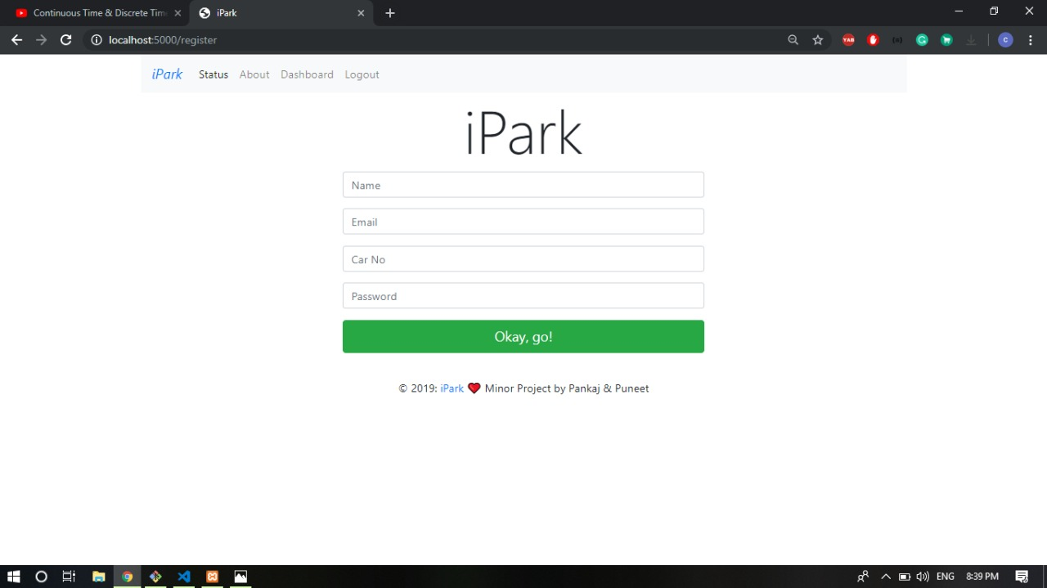

**Fig 6: Registration Page**

**Conclusion**

There are many automated car parking systems already available using technologies such as GSM, wireless transmitter, etc. This project was especially chosen for the purpose of learning more about image processing, as it is one of the most relevant technologies of our times and used in numerous other applications. The algorithm sometimes gives wrong results in character recognition due to small dataset used, which can be improved by training algorithm with more dataset. This project was developed to be implemented in real-time and to evaluate image processing algorithms. The technique of license plate reading is not just limited to car parking, but can also be used in various other applications wherever there is a need for character recognition, e.g. toll booths, car registration applications, traffic control etc.

**Refrences**

1) Sendex youtube channel : <https://www.youtube.com/playlist?list=PLQVvvaa0QuDdttJXlLtAJxJetJcqmqlQq>

2) Coursera:

<https://www.coursera.org/lecture/machine-learning>

3) Graves, Alex, Santiago Fernández, and Jürgen Schmidhuber. "Bidirectional LSTM networks for improved phoneme classification and recognition." Artificial Neural Networks: Formal Models and Their Applications–ICANN 2005. Springer Berlin Heidelberg, 2005. 799-804.

4)  Fernández, Santiago; Graves, Alex; Schmidhuber, Jürgen (2007). "Sequence labelling in structured domains with hierarchical recurrent neural networks". Proc. 20th Int. Joint Conf. On Artificial Intelligence, Ijcai 2007: 774–779